# Objectives:

* Explain the basics of Python and Jupyter Notebooks.
* Summarize the basic functionality of the Python libraries Pandas, NUMPY, SciPy, and Matplotlib
* Identify situations in which statistics are used in everyday life.
* Differentiate between situations in which categorical and continuous variables would be used.
* Calculate the mean, median, and mode of a data set.
* Analyze situations to identify which measure of central tendency is best to use.
* Calculate the variability of a data set.
* Explain what the standard deviation of a data set means.
* Write Python code that calculates summary and descriptive statistics for a data set.

Crucial topics in statistics includes –

* Data gathering
* Summarizing data using descriptive statistics
* Displaying and visualizing data
* Examining relationships between variables
* Probability distributions
* Expected values
* Hypothesis testing
* Introduction to ANOVA (analysis of variance)
* Regression and correlation analysis.

**Week 1:**



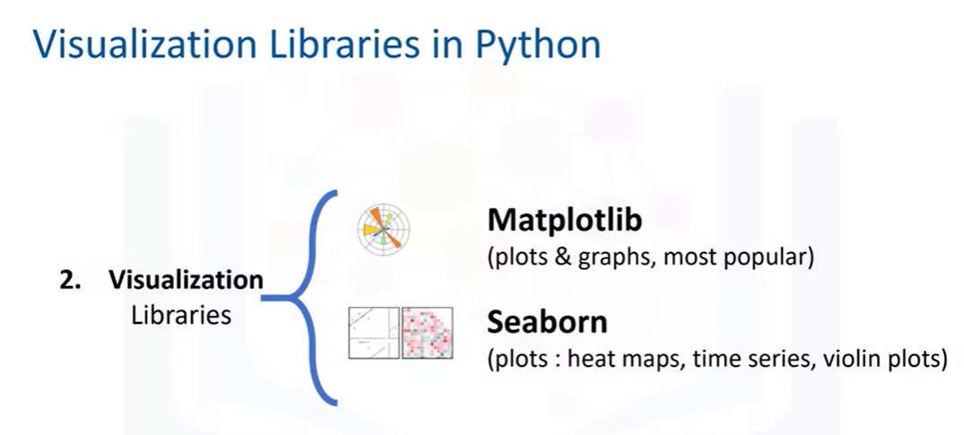

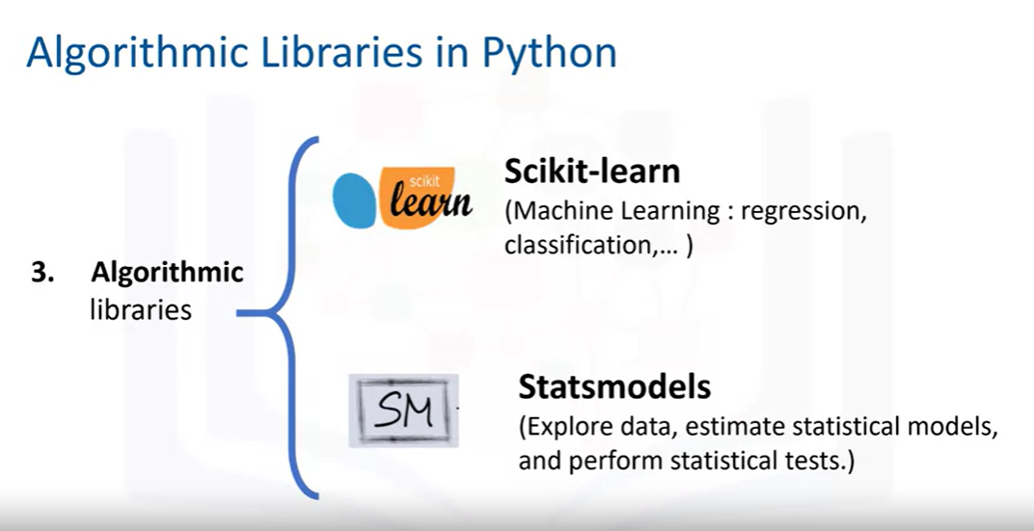

Reading and Saving data formats:

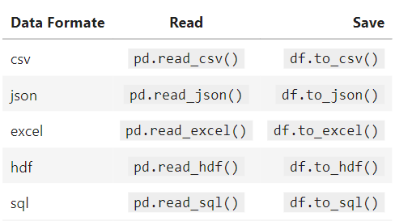

**Week 2:**

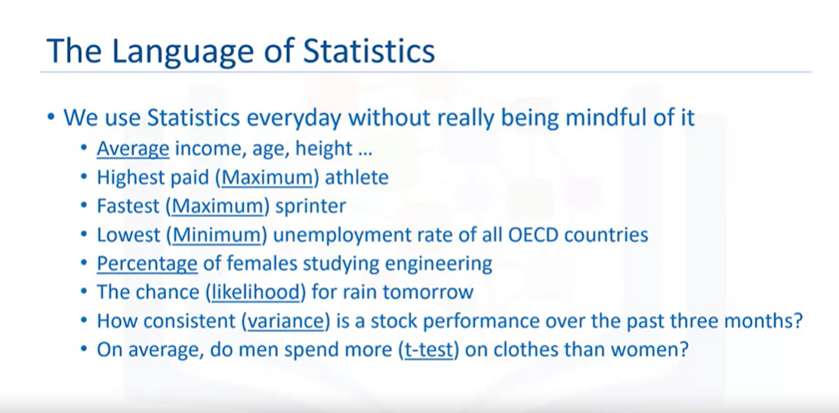

Data types:

* 1. Cross sectional – Measurements taken at one time period
  2. Time series – Data collection over time

Variables:

* Univariate – Data consisting of a single variable to measure some entity
* Multivariate – Data consisting of two or more variables to measure some entity

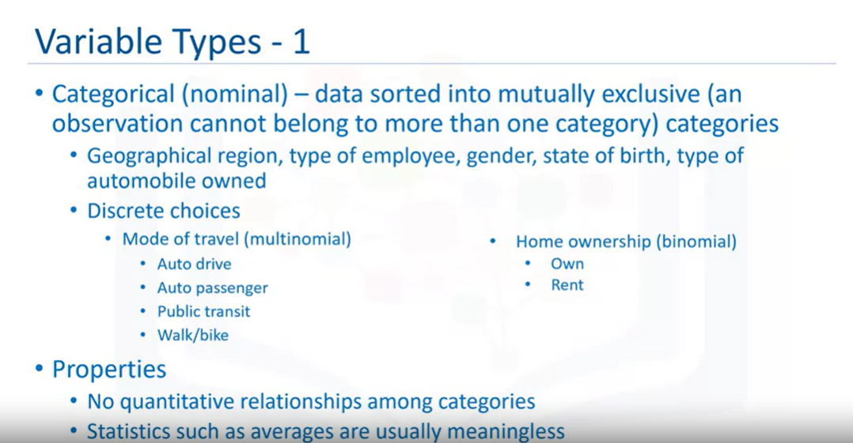

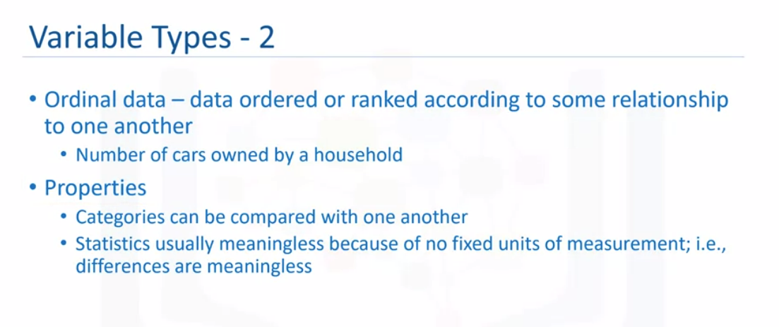

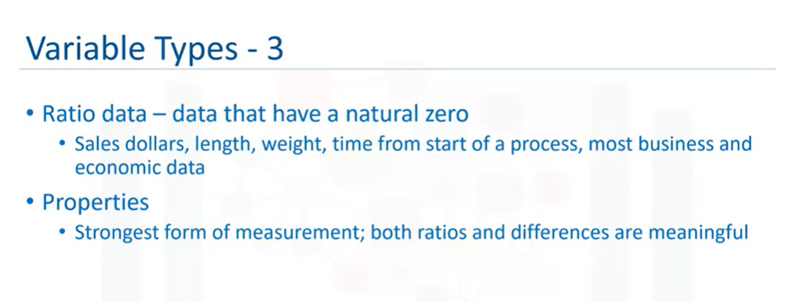

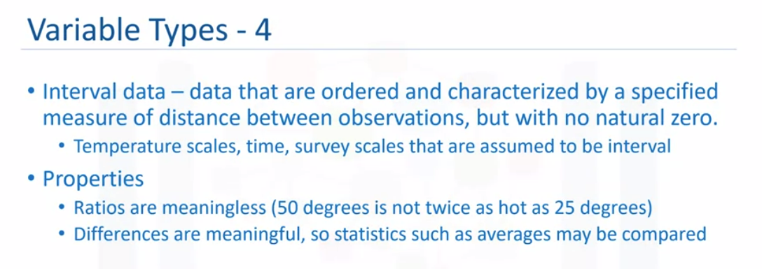

**Measure of central tendency:**

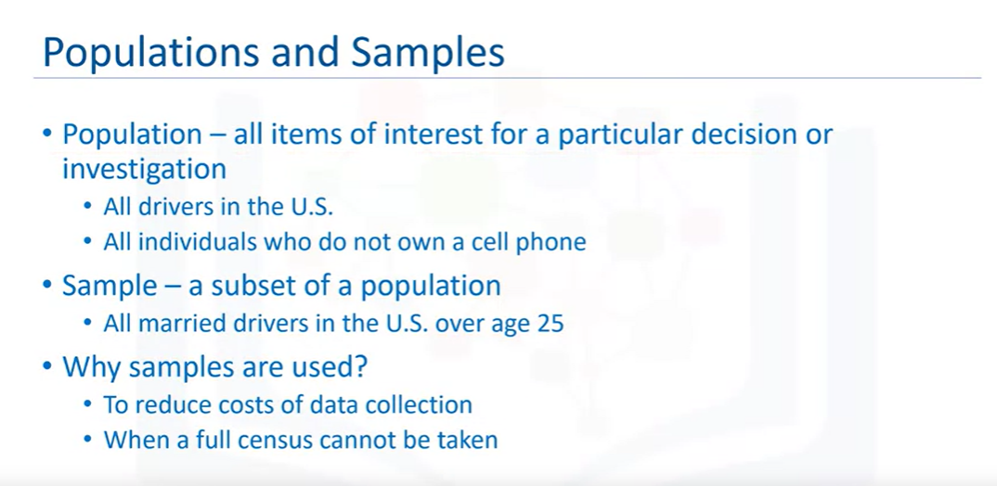

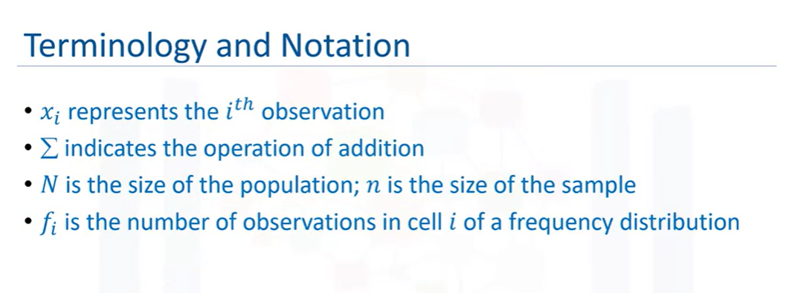

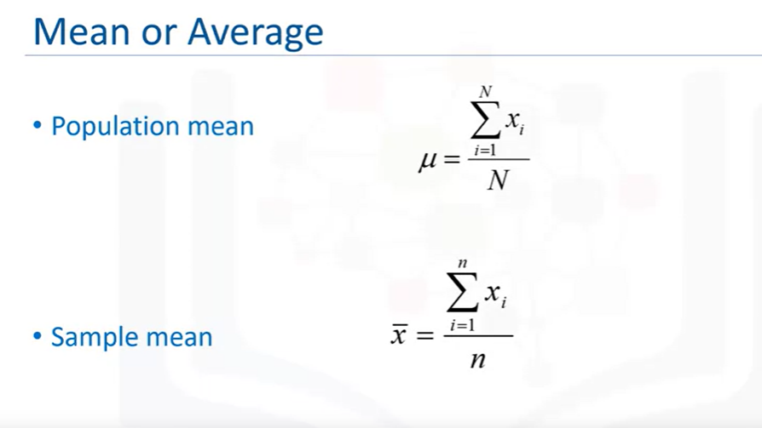

For example, if population mean comes to 100 while sample mean comes to 20, it means the sample considered is a wrong sample.

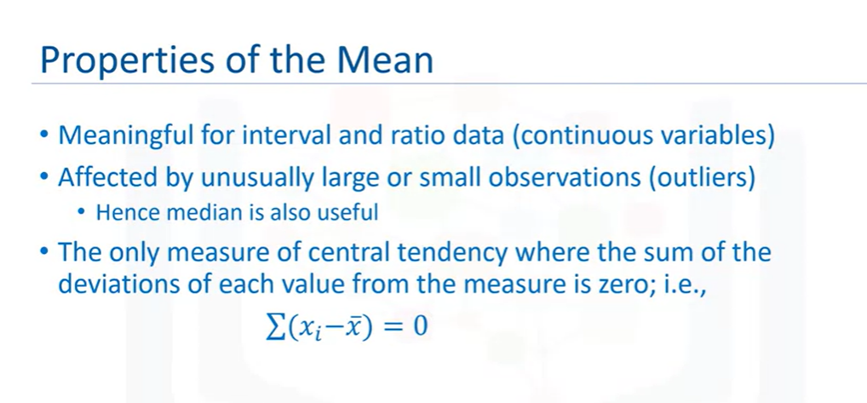

For example,

1. In a class of 4 students, if first student gets 36/100, second gets 38/100, third gets 39/100 and fourth gets 99/100. Average = 53 which is not right. Here 99 is the outlier.
2. Consider another example of outlier in data,

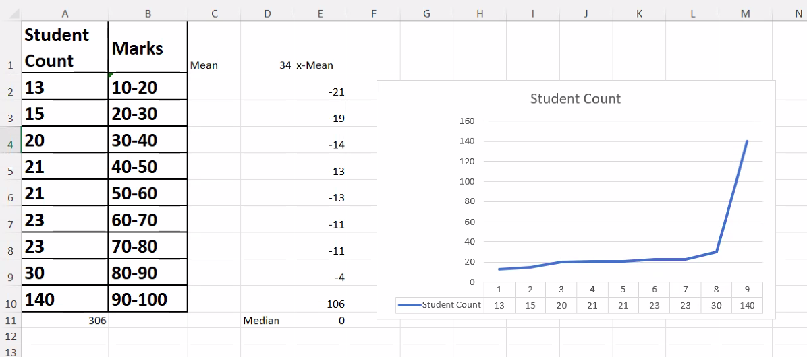

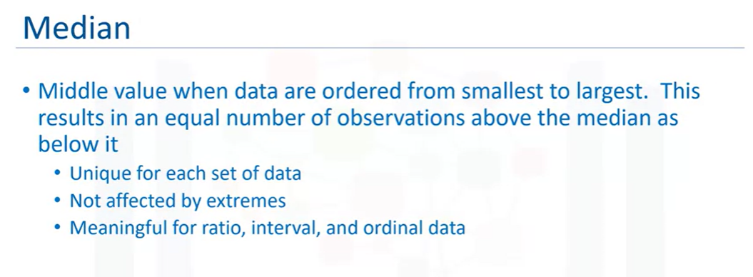

**Measure of Dispersion:**

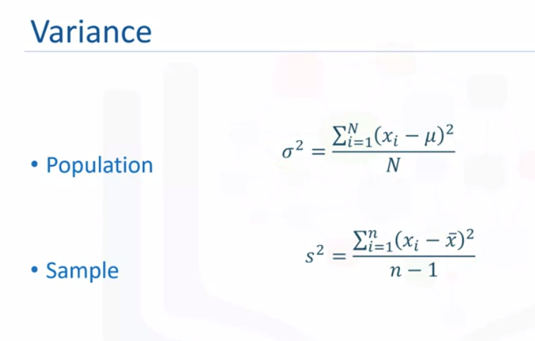

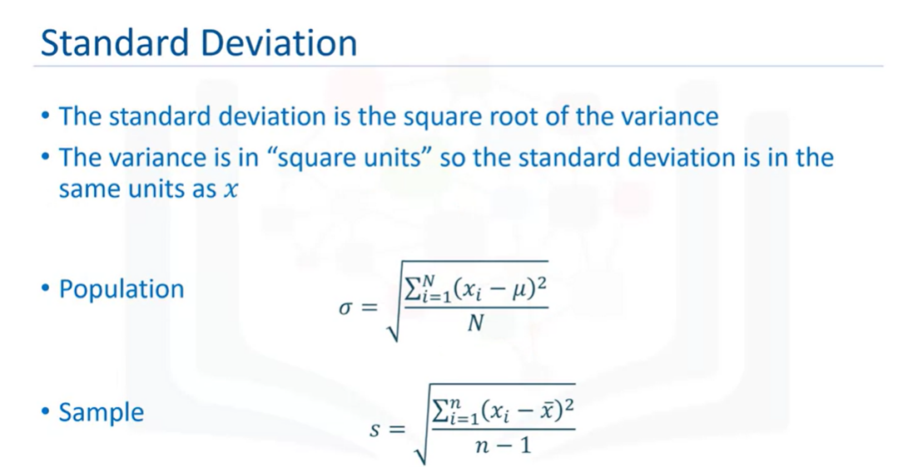

**Week 3:**

Chart suggestion:

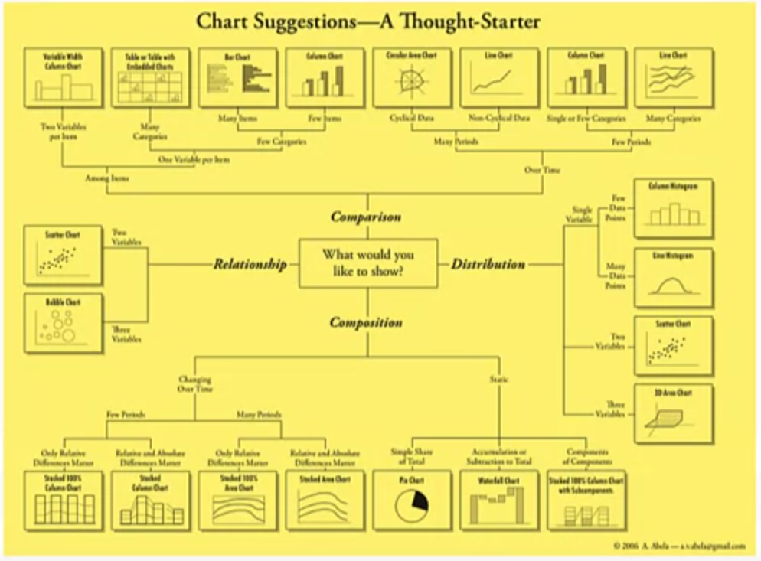

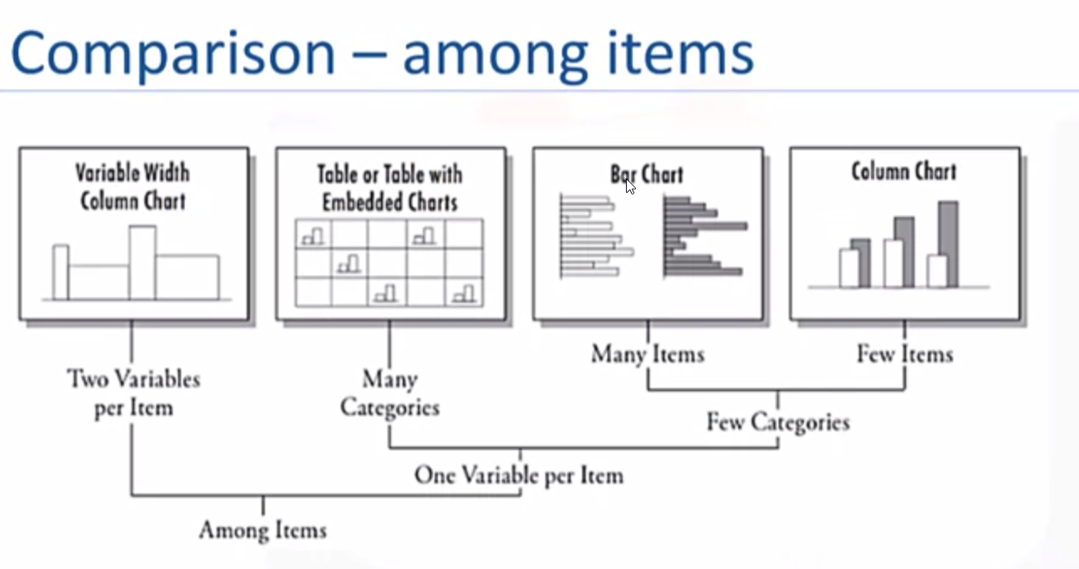

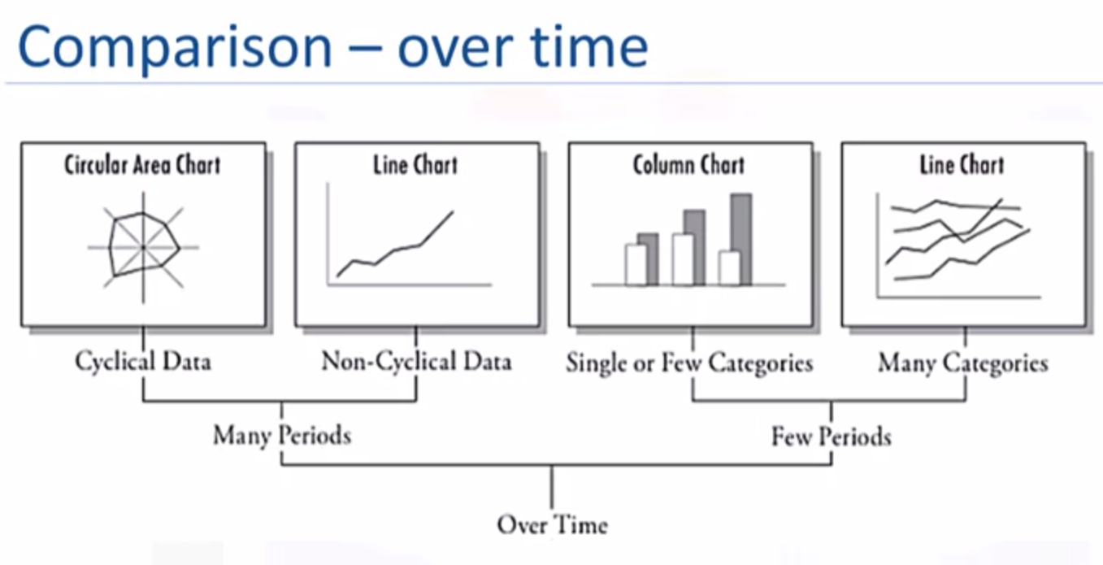

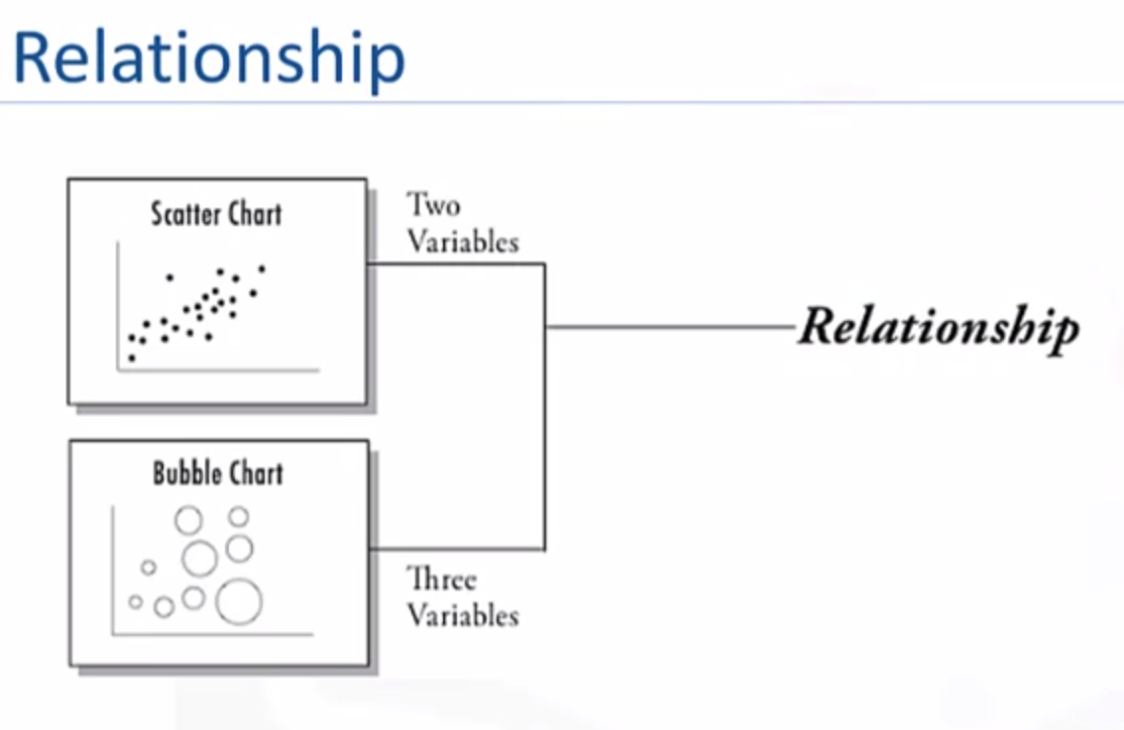

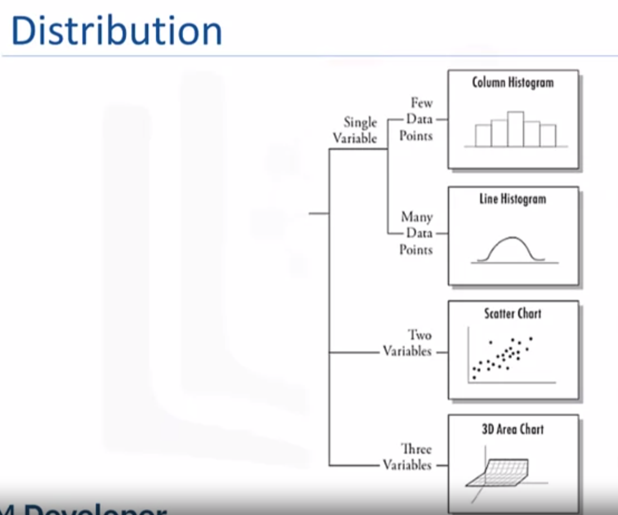

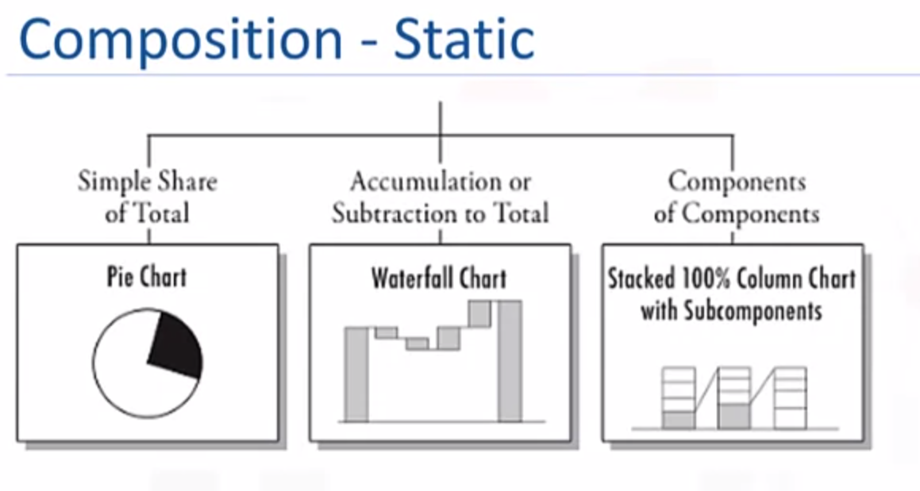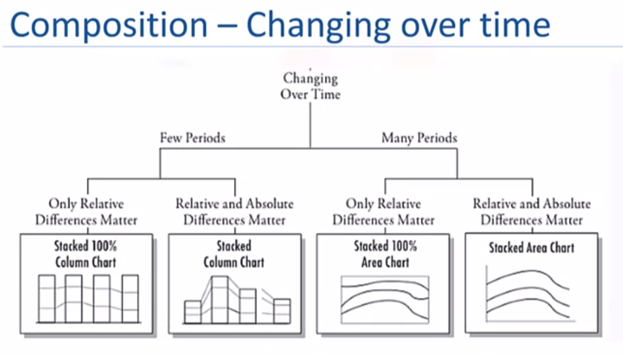

We use seaborn and matplotlib packages for visualization in python

**Statistics by Groups**

For distribution and variance to be illustrated in charts, we use histogram. For displaying mean, median and outliers, we use box plot.

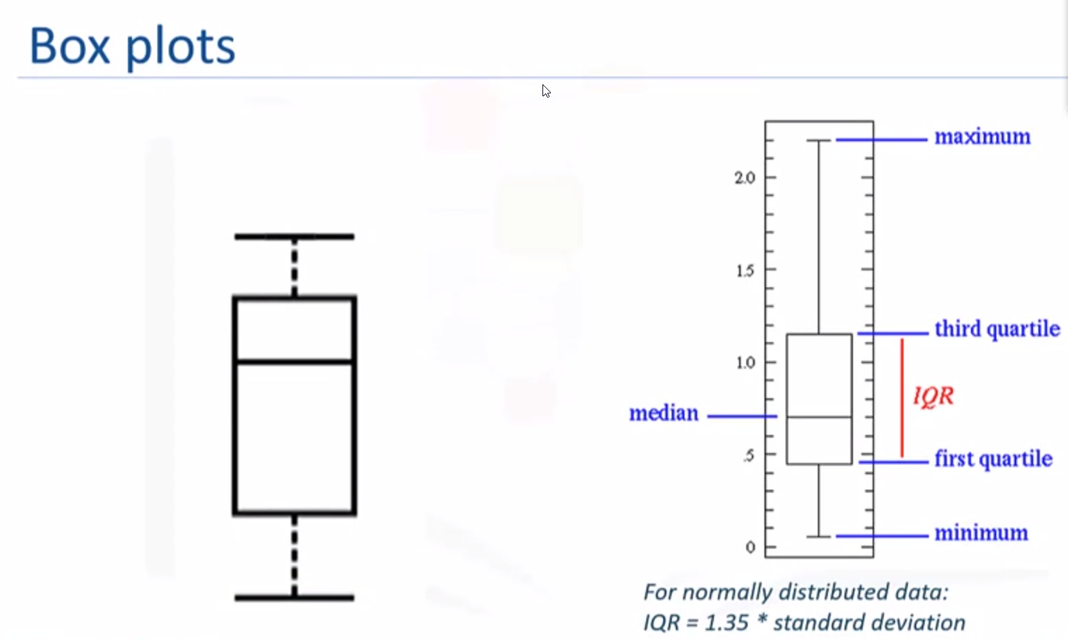

**Week 4: Probability distributions:**

The probability associated with any outcome or event must fall in the zero and one interval (0-1)

* The probability of all possible outcomes must equate to 1
* For example, possibility of head or tail in tossing a coin => ½ + ½ = 1

F(x) represents the cumulative distribution function or cdf and f(x) which represents the probability density function, or pdf, of the continuous random variable.

Alpha and p-value are commonly used terms in statistical analysis. Both are used in hypothesis testing when we are trying to reject or fail to reject a given hypothesis. Alpha is assumed while P-value is a calculated value and an output you get as part of conducting your hypothesis test.

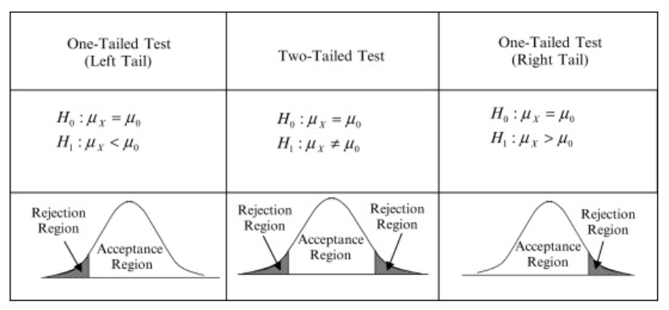

How do I calculate p-value from test statistic?

Left-tailed test: p-value = cdf(x).

Right-tailed test: p-value = 1 - cdf(x).

Two-tailed test: p-value = 2 × min{cdf(x) , 1 - cdf(x)}.

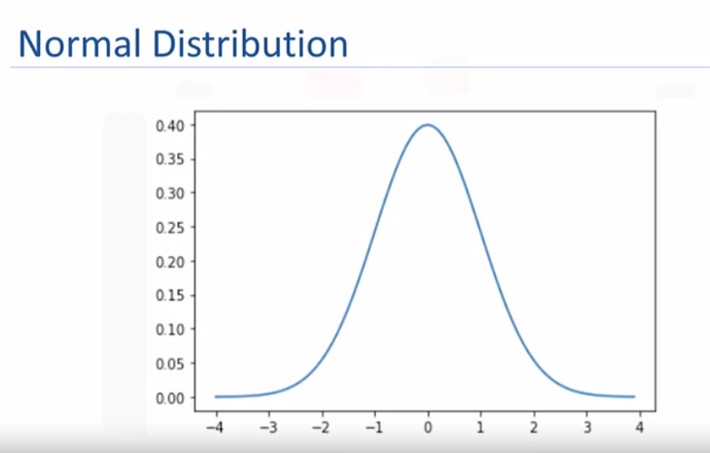

Normal distribution always follows a bell curve

Formula:

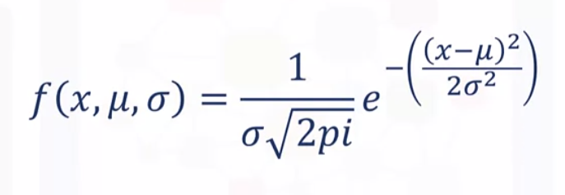

Normal distribution is for population data while t-distribution is for sample data (subset of population data)

What is Degree of freedom?

To performing t-test on data to test statistical significance, we perform the following:

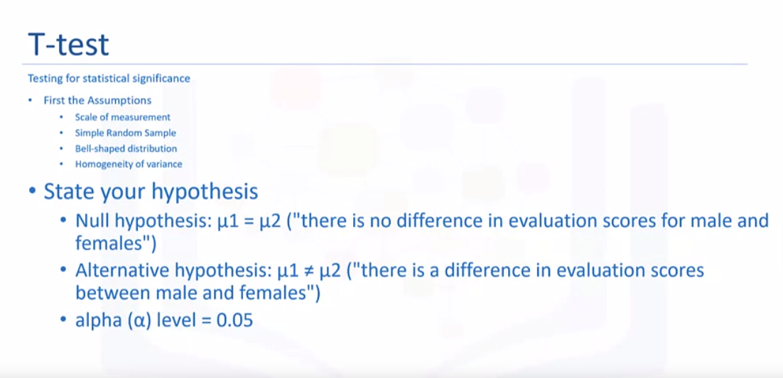

Probability of getting a high or low teaching evaluation score:

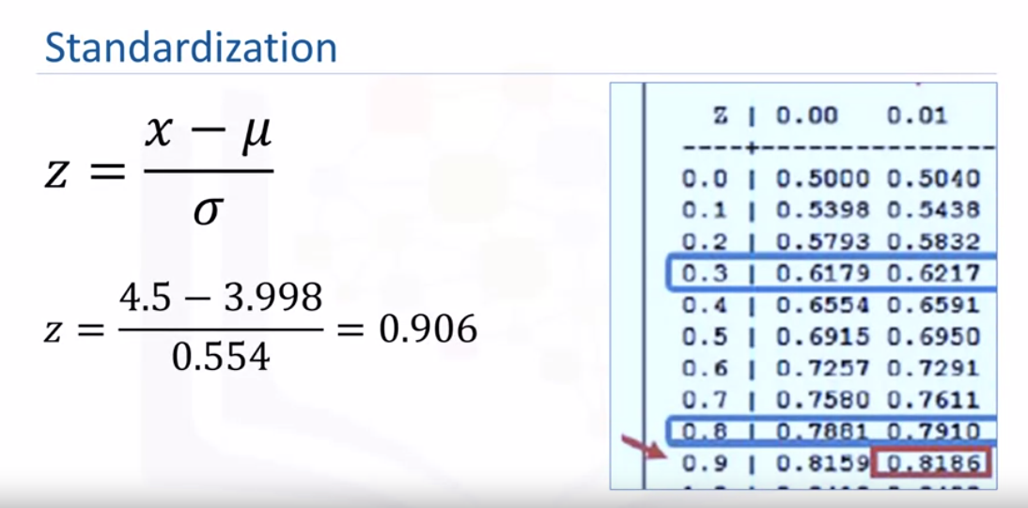

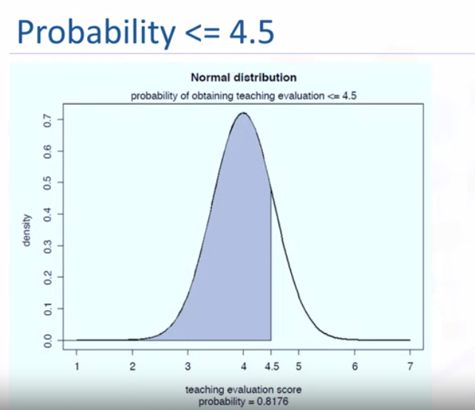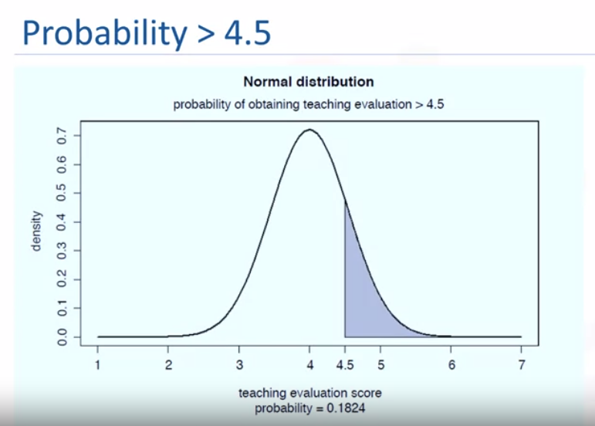

Same thing using python code:

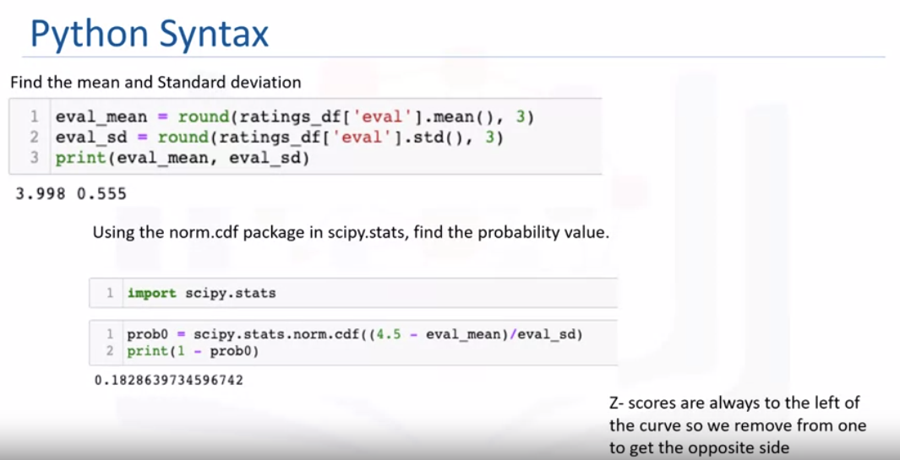

# **Standard Normal Table:**

You can use the z-table to find a set of “less-than” probabilities for a wide range of *z*-values. To use the z*-*table to find probabilities:

1. Go to the **row** that represents the first digit and the first digit after the decimal point of your *z*-value. (e.g 0.9 in 0.93)
2. Go to the **column** that represents the second digit after the decimal point of your *z*-value. (e.g 3 in 0.93, this will be 0.03 in the column)
3. Intersect the row and column from Steps 1 and 2.

For example, suppose you want to find the probability of z-score less than 1.44 denoted as *p*(*Z* < 1.44). Using the second *Z*-table below, find the row for 1.4 and the column for 0.04. Intersect that row and column to find the probability: 0.92507. Therefore *p*(*Z* < 1.44) = 0.92507.

The area under any normal curve (including the standardized normal curve) is 1, that means that, *p*(*Z* < 1.44) + *p*(*Z* > 1.44) =1. Therefore, the probability of z-score greater than 1.44 i.e. *p*(*Z* > 1.44) = 1 – *p*(*Z* < 1.44) which equals 1 – 0.92507 which equals 0.07493.

Suppose you want to look for *p*(*Z* < –1.44). You find the row for –1.14 and the column for 0.04. Intersect the row and column and you find 0.07493. That means *p*(*Z* < –1.44) = 0.07493. This happens to be the same as the value of *p*(*Z* > +1.44). This is because the normal distribution is symmetric. So the tail of the curve below –1.44 representing *p*(*Z* < –1.44) looks exactly like the tail above 1.44 representing *p*(*Z* > +1.44).

You can also do a reverse lookup, assuming you are told that the age of grade 1 kindergarten pupils in Kampala city is normally distributed with a mean of 6 years. If only 0.71% (same as 0.0071) of the pupils are 8 years and above, what is the z-score?

We can look within the negative box for the z-score closest to 0.0071. In this case -2.45, but because we are looking at the right-tailed test, we get rid of the negative sign i.e.z-value = 2.45 (Note: if it was a left-tailed test e.g. 0.71% of them were less than 3 years old, we will use the value as-is) **OR**

We can look within the positive table, for the value that corresponds to 1-0.0071 = 0.99286 (we do this because the standard normal table always gives you values to the left, so to get values to the right, you will have to remove from 1). The value that corresponds to this will be 2.45.

To make things easier, you can also use a "z-score from p-value" or a "p-value from z-score" calculator online.

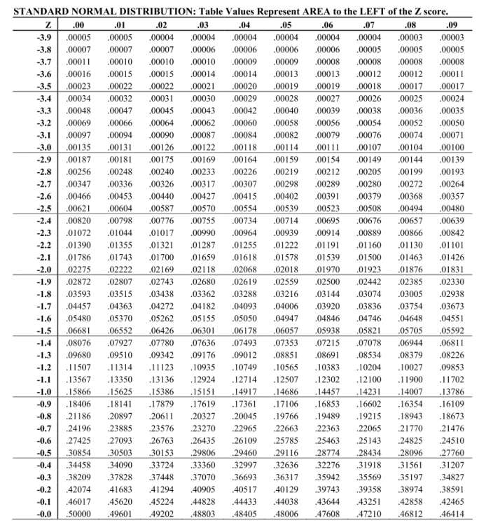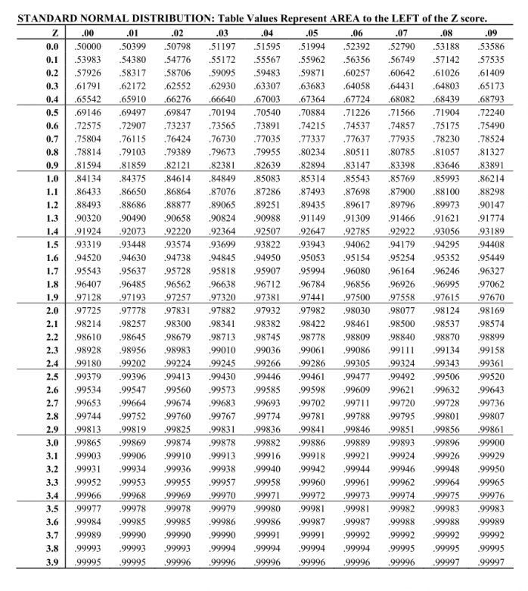

**Key points:**

There are under a conditional cumulative density function is 1

**Week 5: Testing for mean differences and relationships:**

Z test – should be used if population standard deviation is known

T test - should be used if population standard deviation is not known

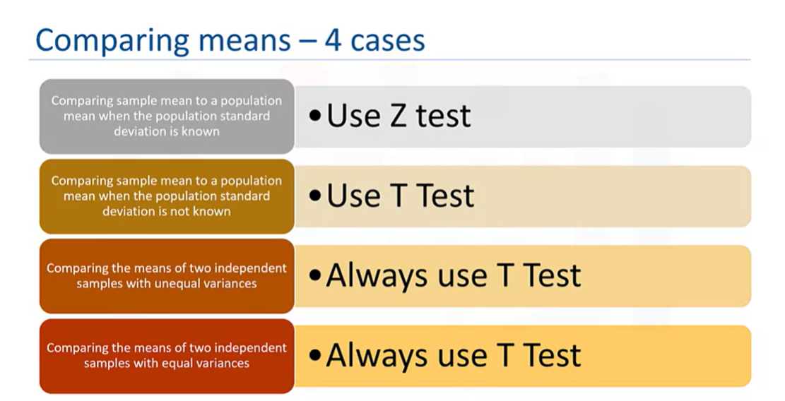

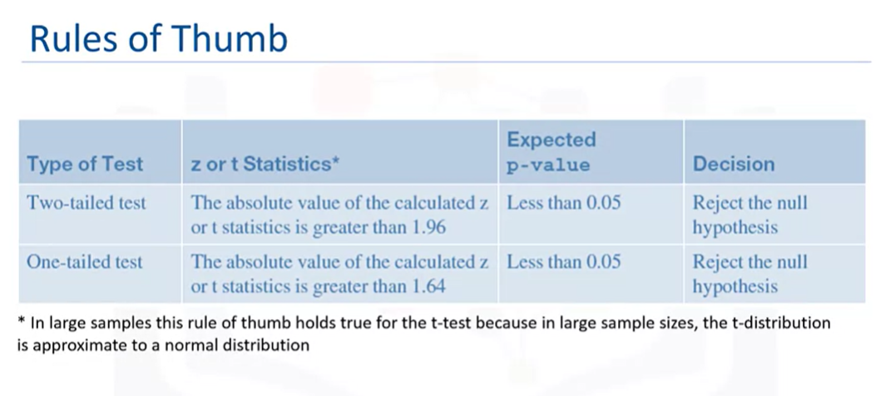

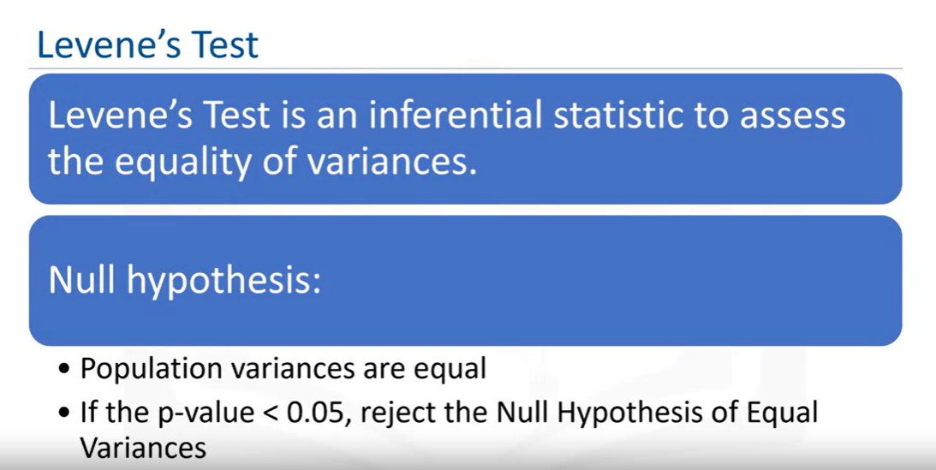

Python code for above is,

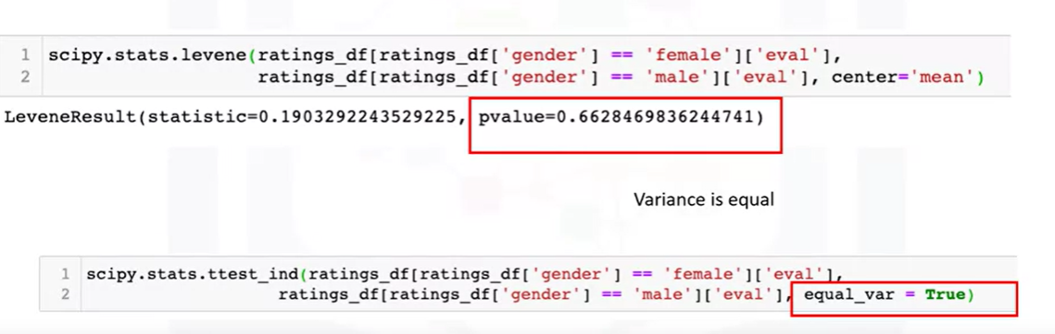

Mathematical calculation for above will be,

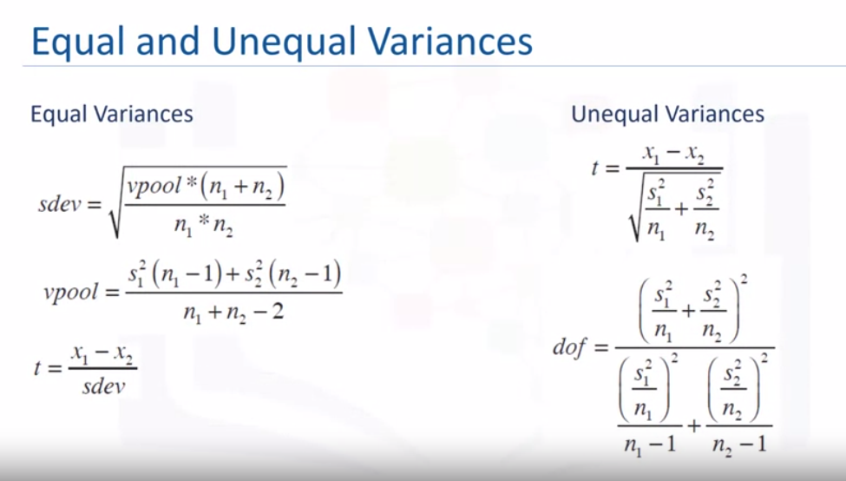

**ANOVA: Analysis of Variance**

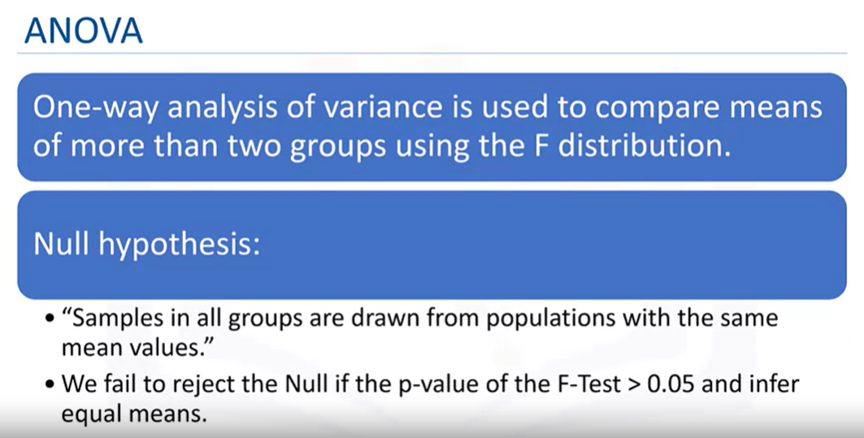

**Correlation tests:**

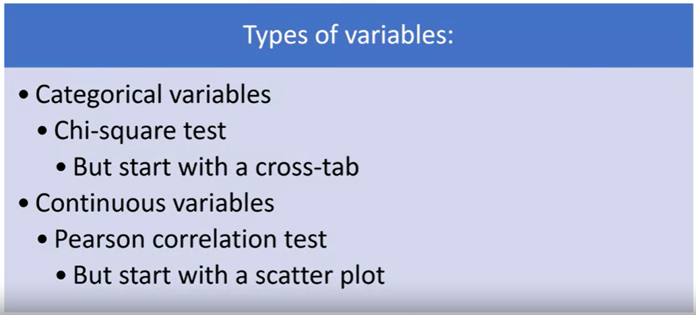

For example, is there an association between gender and tenure?

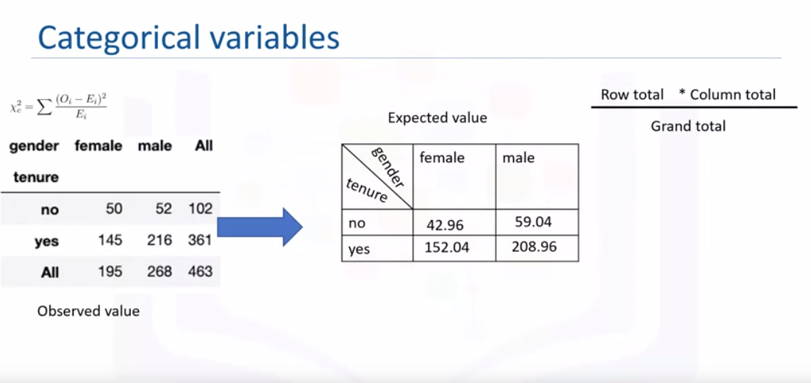

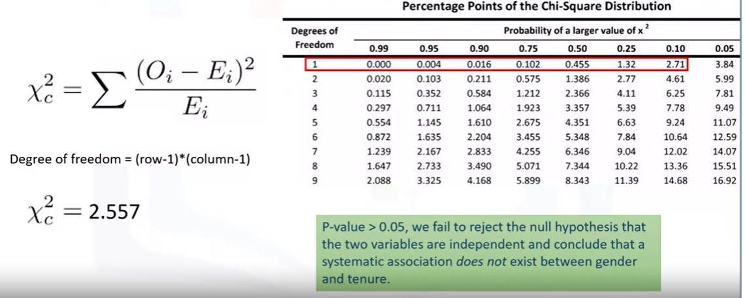

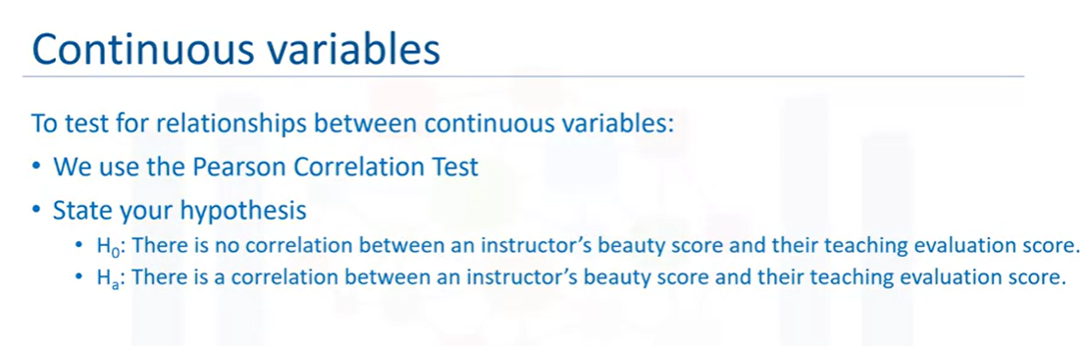

For example, is teaching evaluation score correlated with beauty score?

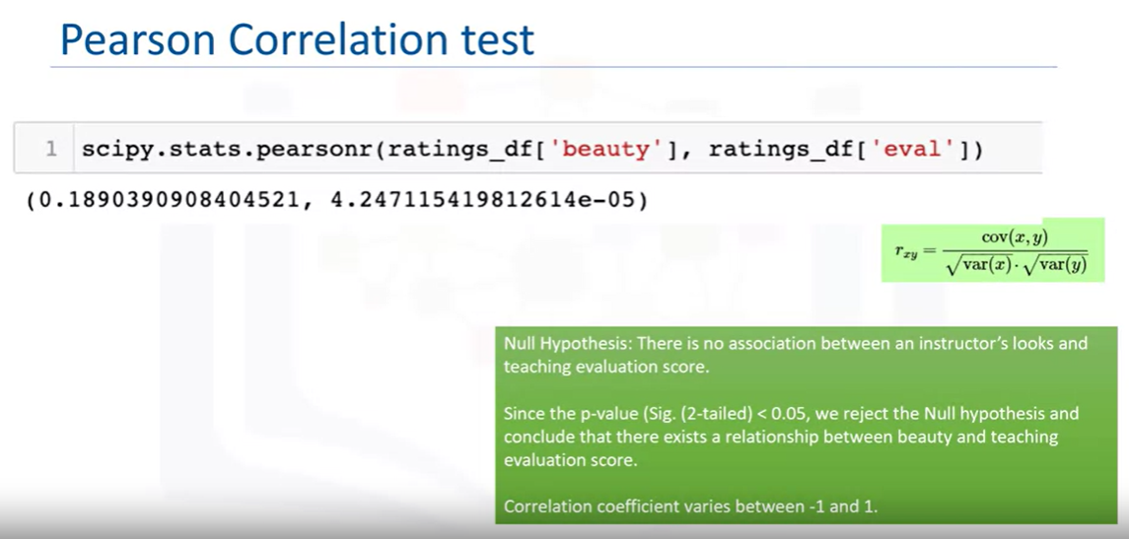

**What is hypothesis testing?**

The goal of hypothesis testing is to answer the question, “Given a sample and an apparent effect, what is the probability of seeing such an effect by chance?” The first step is to quantify the size of the apparent effect by choosing a test statistic (t-test, ANOVA, etc). The next step is to define a null hypothesis, which is a model of the system based on the assumption that the apparent effect is not real. Then compute the p-value, which is the probability of the null hypothesis being true, and finally interpret the result of the p-value, if the value is low, the effect is said to be statistically significant, which means that the null hypothesis may not be accurate.

## Regression in place of Hypothesis Testing:

**Regression Analysis:** The goal of regression analysis is to describe the relationship between one set of variables called the dependent variables, and another set of variables, called independent or explanatory variables. When there is only one explanatory variable, it is called simple regression.

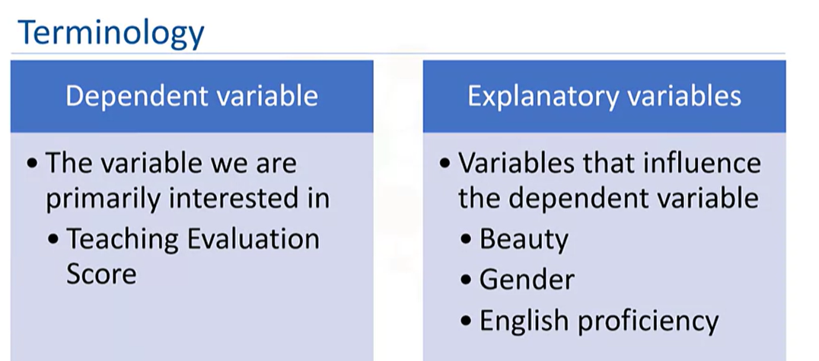

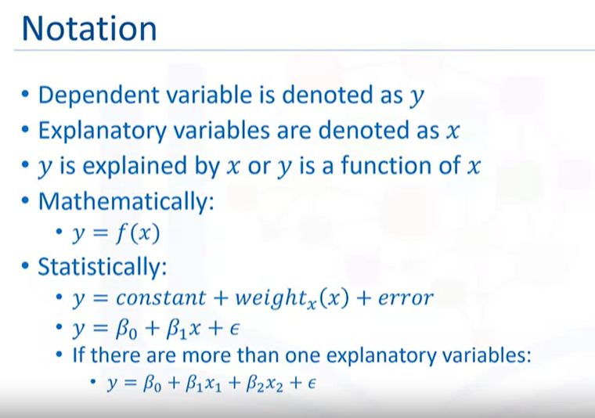

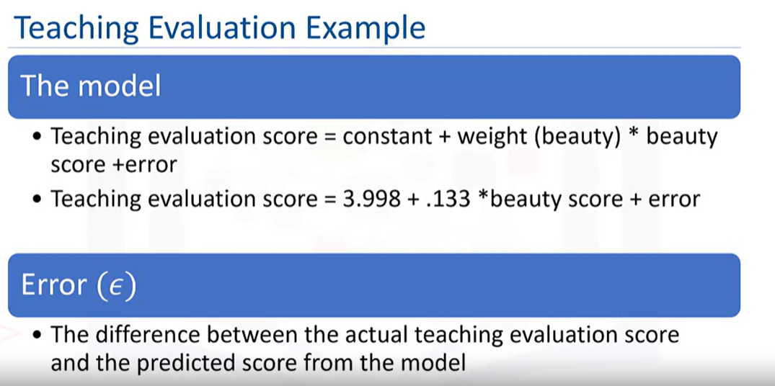

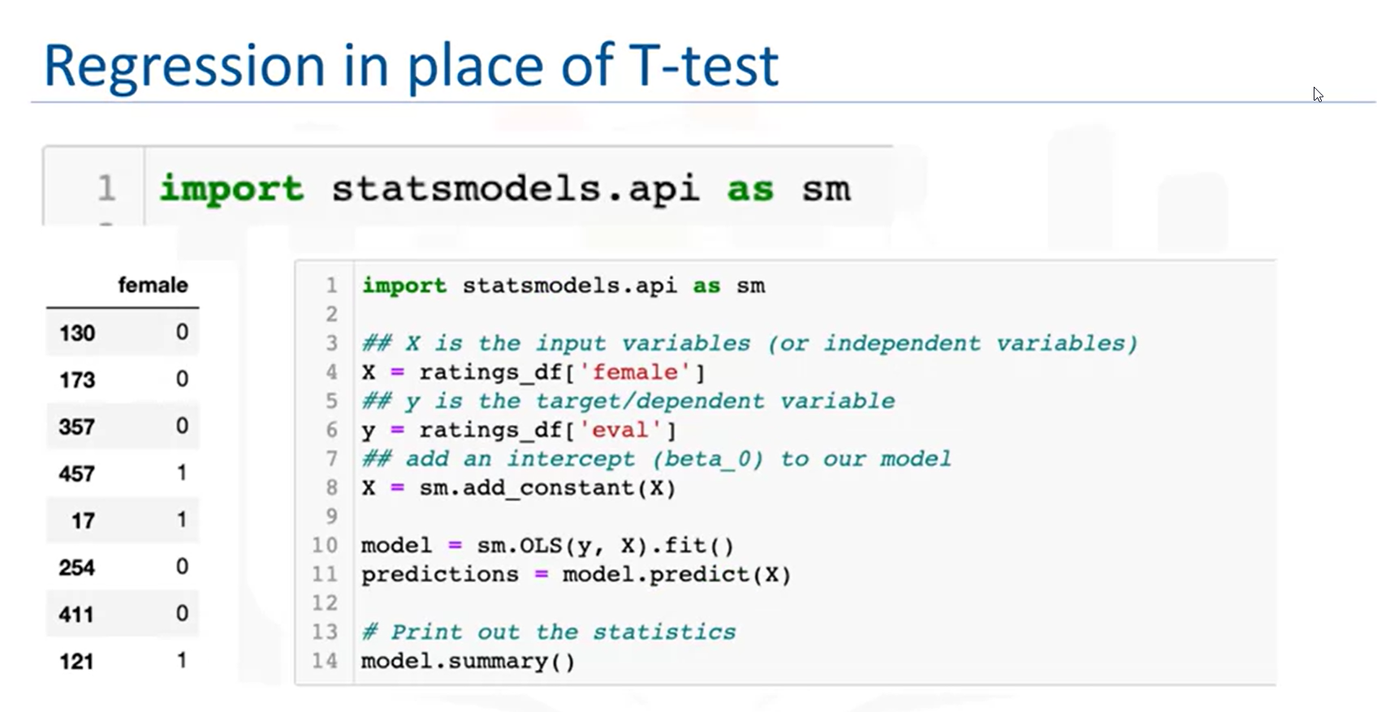

Model Summary:

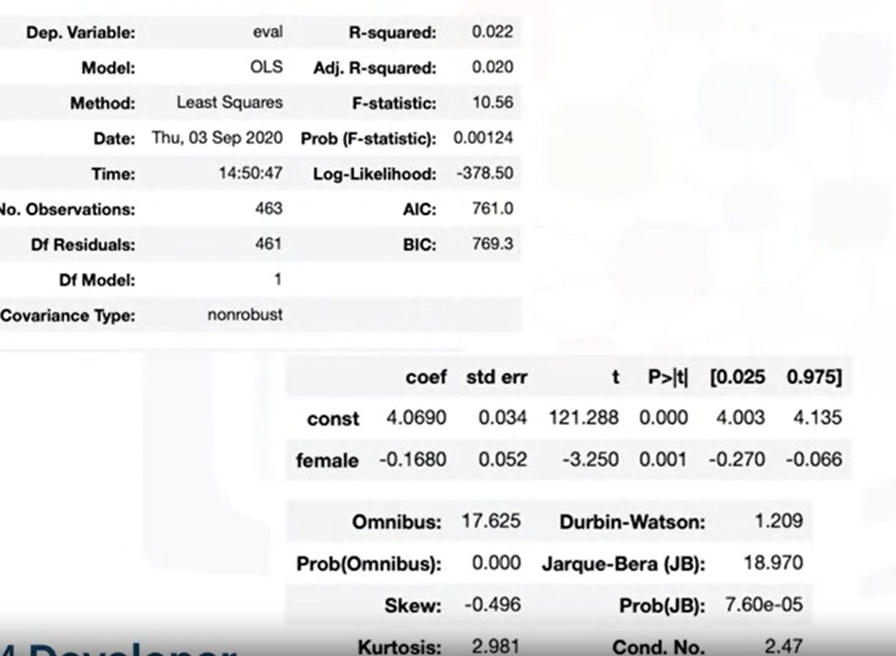

**Conclusion:** Like the t-test, the p-value is less than the alpha (α) level = 0.05, so we reject the null hypothesis as there is evidence that there is a difference in mean evaluation scores based on gender. The coefficient -0.1680 means that females get 0.168 scores less than men.

**OLS:** The OLS() function of the statsmodels. api module is used to perform OLS regression. It returns an OLS object. Then fit() method is called on this object for fitting the regression line to the data. For example,

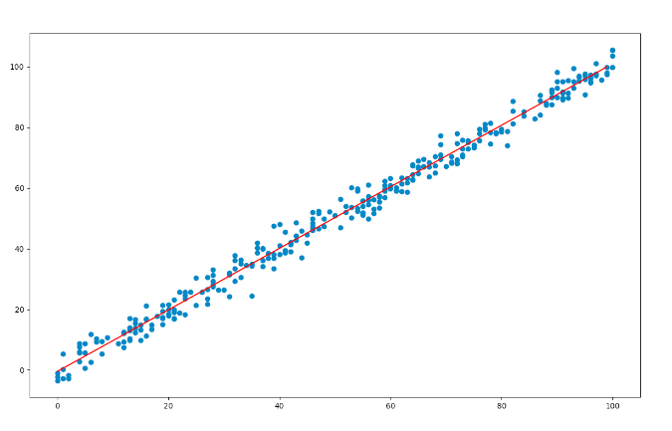

**Regression in place of ANOVA:**

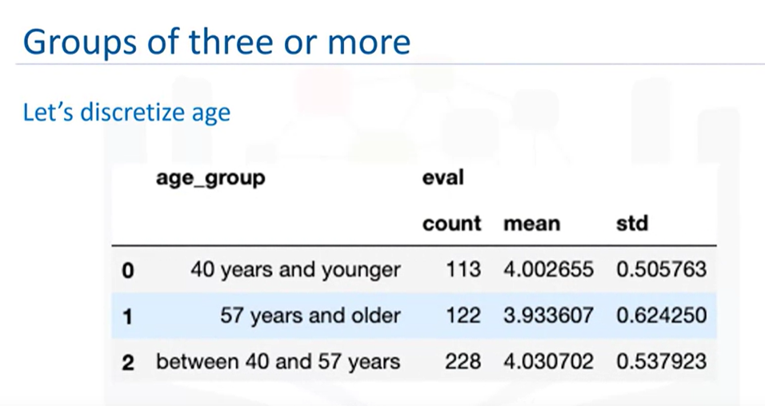

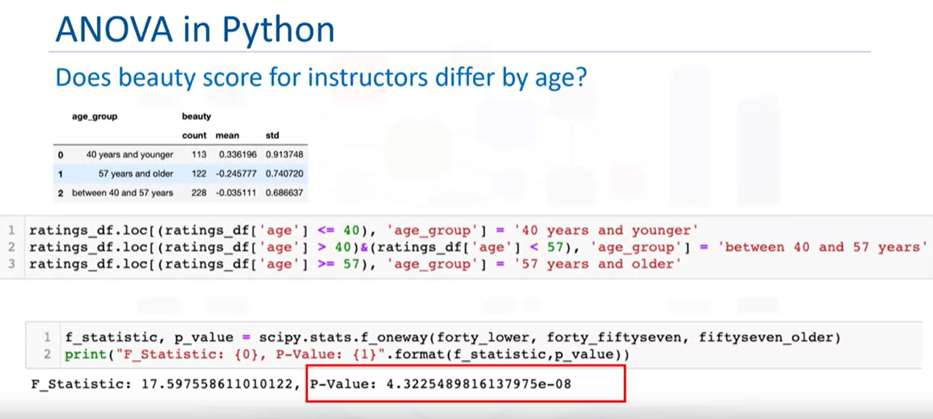

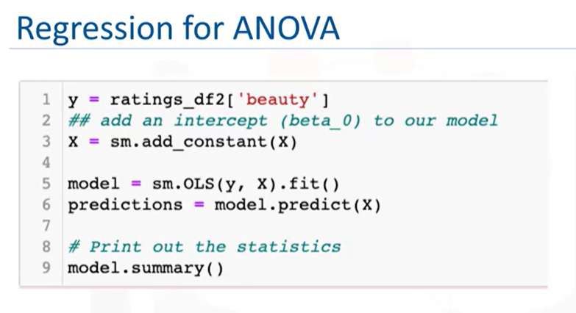

Model Summary:

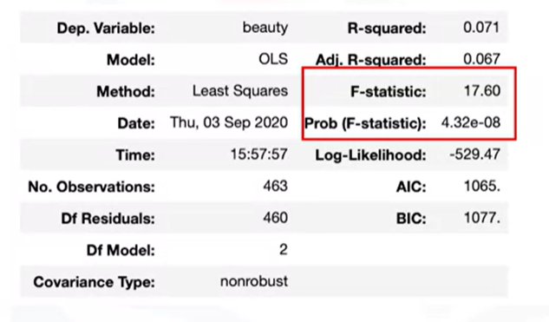

**Conclusion:** We can also see the same values for ANOVA like before and we will reject the null hypothesis since the p-value is less than 0.05 there is significant evidence that at least one of the means differ.

**Regression with ANOVA Option 2:**

Create dummy variables - A dummy variable is a numeric variable that represents categorical data, such as gender, race, etc. Dummy variables are dichotomous, i.e they can take on only two quantitative values.

See example in downloaded Jupiter notebook.

**Notes:**  
[1] Standard Errors assume that the covariance matrix of the errors is correctly specified.  
[2] The smallest eigenvalue is 5.11e-28. This might indicate that there are  
strong multicollinearity problems or that the design matrix is singular.

You will get the same results and conclusion

**Regression in place of Correlation:**

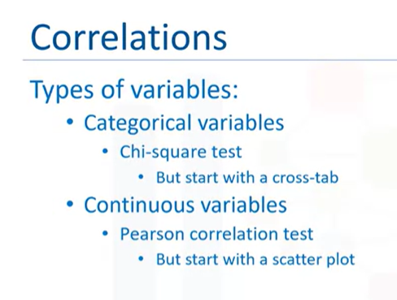

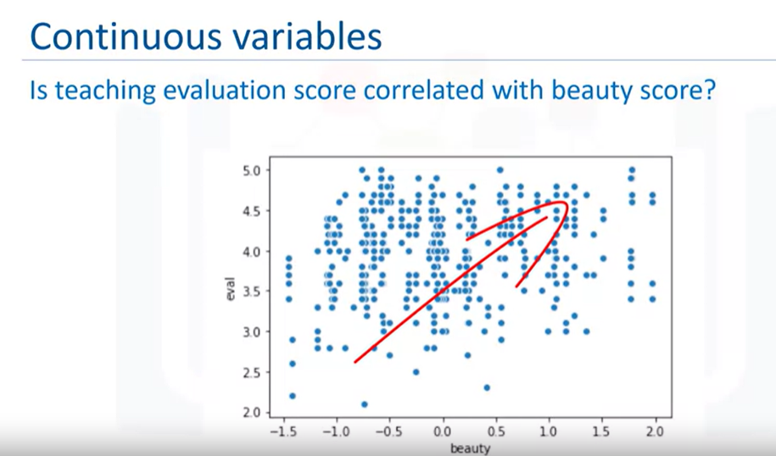

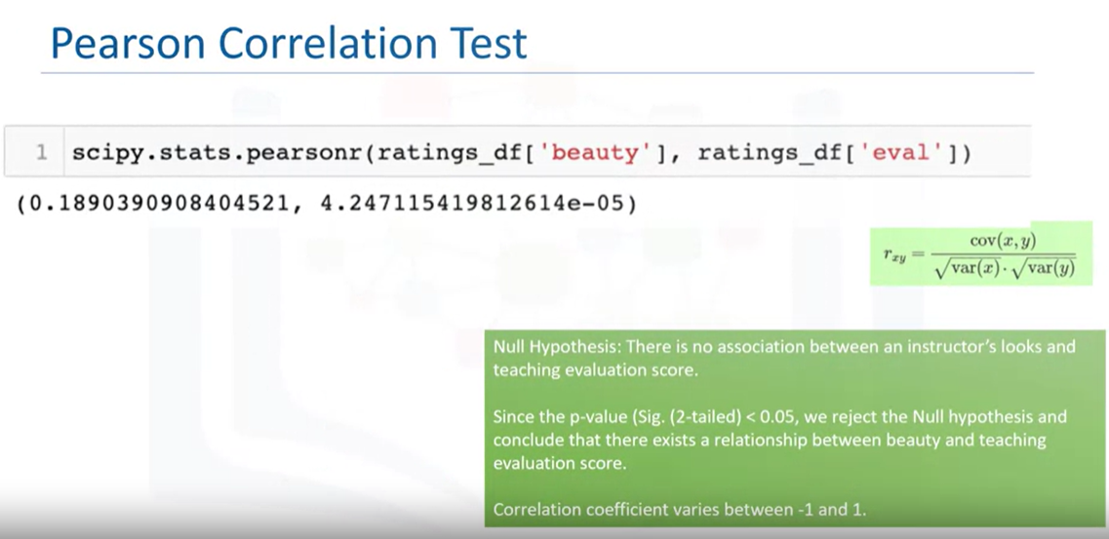

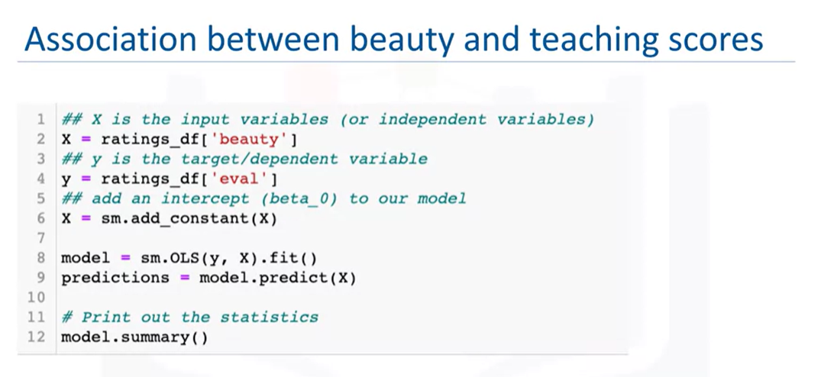

Model Summary:

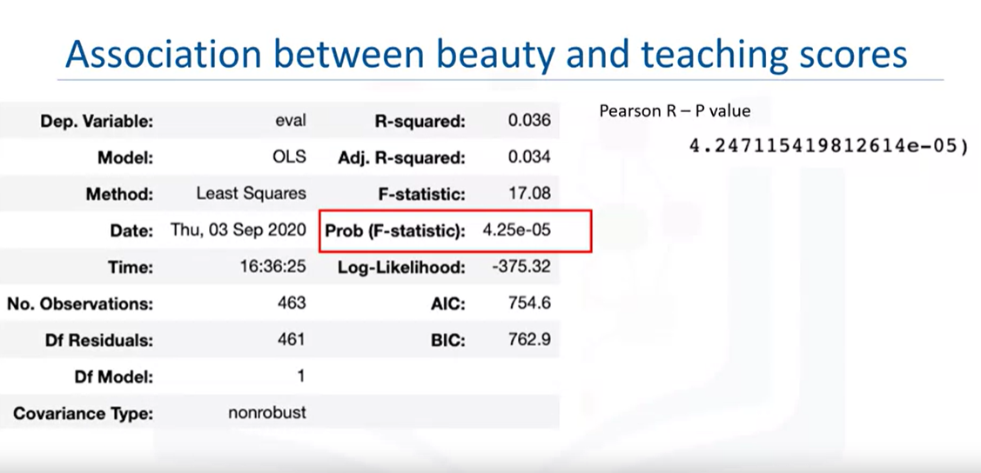

Correlation coefficient = sqrt(R-squared)

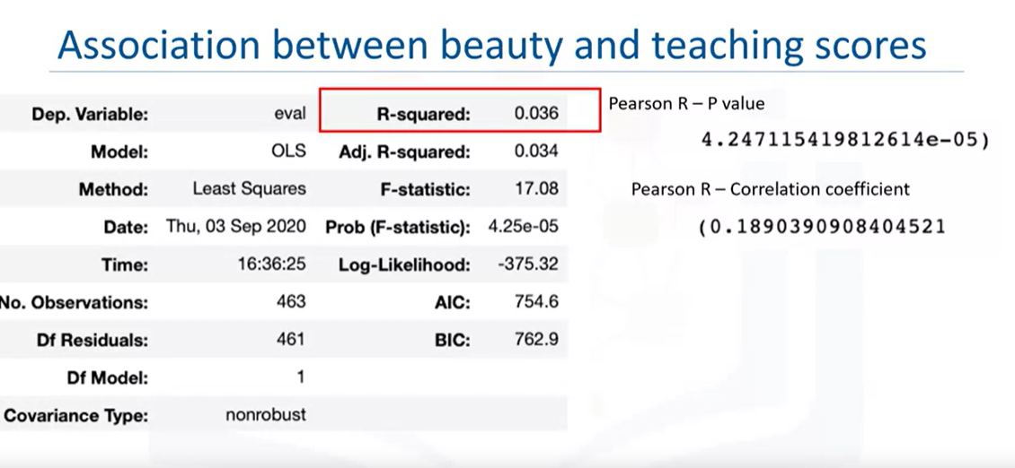

**Conclusion:** p < 0.05 there is evidence of correlation between beauty and evaluation scores

**Week 7:**

# **Project Case Scenario:**

**Project Scenario:** You are a Data Scientist with a housing agency in Boston MA, you have been given access to a previous dataset on housing prices derived from the U.S. Census Service to present insights to higher management. Based on your experience in Statistics, what information can you provide them to help with making an informed decision? Upper management will like to get some insight into the following.

* Is there a significant difference in the median value of houses bounded by the Charles river or not?
* Is there a difference in median values of houses of each proportion of owner-occupied units built before 1940?
* Can we conclude that there is no relationship between Nitric oxide concentrations and the proportion of non-retail business acres per town?
* What is the impact of an additional weighted distance to the five Boston employment centres on the median value of owner-occupied homes?

Using the appropriate graphs and charts, generate basic statistics and visualizations that you think will be useful for the upper management to give them important insight given the question they are asking, in your graphs, include an explanation of each statistic.

**Project Tasks:**

**Task 1:** Familiarize yourself with the dataset:

The following describes the dataset variables:

* CRIM - per capita crime rate by town
* ZN - proportion of residential land zoned for lots over 25,000 sq.ft.
* INDUS - proportion of non-retail business acres per town.
* CHAS - Charles River dummy variable (1 if tract bounds river; 0 otherwise)
* NOX - nitric oxides concentration (parts per 10 million)
* RM - average number of rooms per dwelling
* AGE - proportion of owner-occupied units built prior to 1940
* DIS - weighted distances to five Boston employment centres
* RAD - index of accessibility to radial highways
* TAX - full-value property-tax rate per $10,000
* PTRATIO - pupil-teacher ratio by town
* LSTAT - % lower status of the population
* MEDV - Median value of owner-occupied homes in $1000's

**Task 2:** (Optional) If you do not already have an instance of Watson Studio, create an IBM Cloud Lite account and provision an instance of Waston Studio.

**Task 3:** Load the dataset in a Jupyter Notebook using Watson Studio.

**Task 4:** Generate basic statistics and visualizations for upper management.

For all visualizations, please include a title in each graph and appropriate labels

Generate the following and explain your findings:

* For the "Median value of owner-occupied homes" provide a **boxplot**
* Provide a **bar plot** for the Charles river variable
* Provide a **boxplot** for the MEDV variable vs the AGE variable. (Discretize the age variable into three groups of 35 years and younger, between 35 and 70 years and 70 years and older)
* Provide a **scatter plot** to show the relationship between Nitric oxide concentrations and the proportion of non-retail business acres per town. What can you say about the relationship?
* Create a **histogram** for the pupil to teacher ratio variable

**Task 5:** Use the appropriate tests to answer the questions provided.

* Is there a significant difference in median value of houses bounded by the Charles river or not? (T-test for independent samples)
* Is there a difference in Median values of houses (MEDV) for each proportion of owner occupied units built prior to 1940 (AGE)? (ANOVA)
* Can we conclude that there is no relationship between Nitric oxide concentrations and proportion of non-retail business acres per town? (Pearson Correlation)
* What is the impact of an additional weighted distance to the five Boston employment centres on the median value of owner occupied homes? (Regression analysis)

Be sure to:

1. State your hypothesis.
2. Use α = 0.05
3. Perform the test Statistics.
4. State the conclusion from the test.

**Task 6:** Share your Jupyter Notebook.